Lab Report

By: Jahmil Ally (501045419)

# Observations and Analysis

## Q1:

Output:

I'm in method E // is executed first because it has the highest priority (lowest number: `0`).

I'm in method A // has the same priority as D but they are executed in the order they are declared.

I'm in method D

I'm in method B //has no priority like C and are executed last in the order they are declared.

I'm in method C

## Q2:

## Q3:

## Q4:

## Q5:

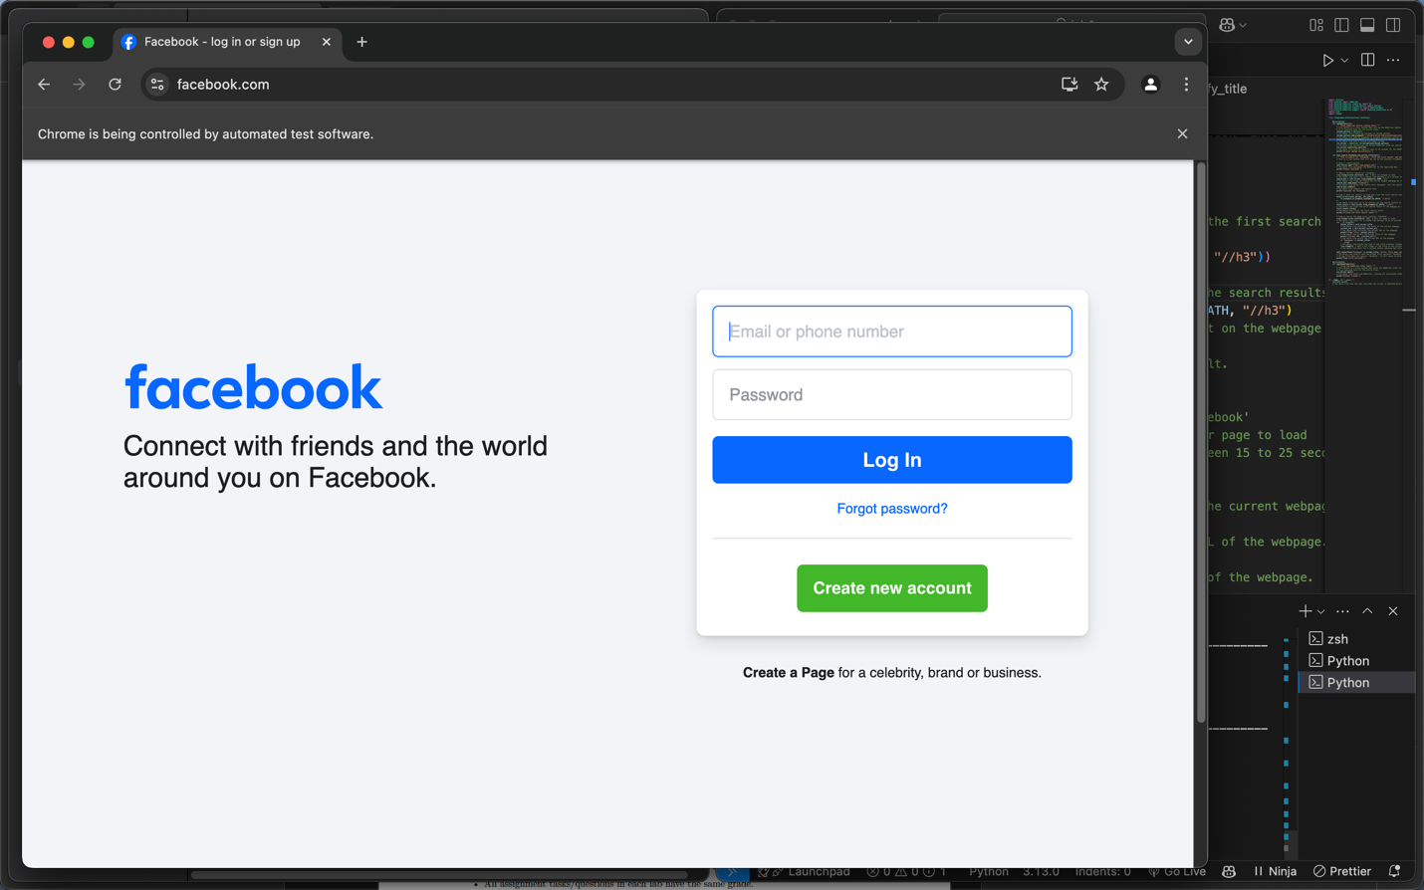

## Q6:

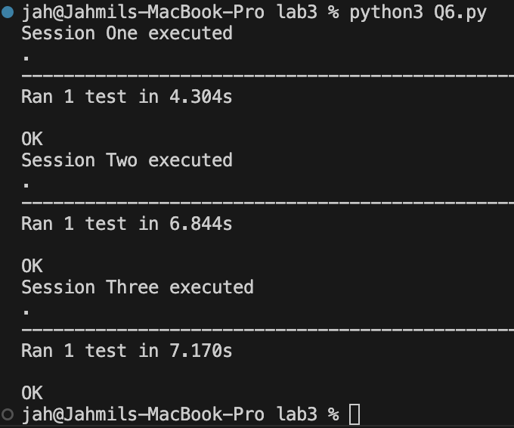

## Q7:

# Appendix:

## Q2:

## Q3:

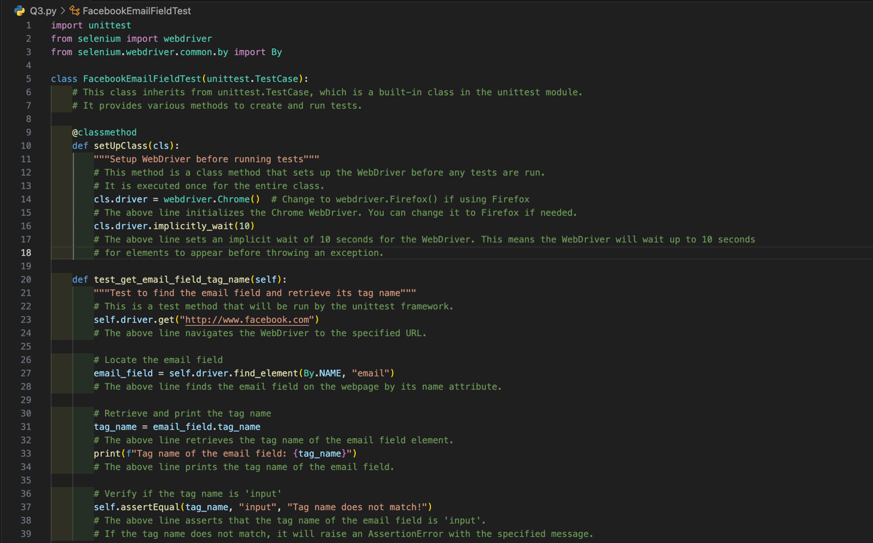

## Q4:

## Q6:

## Q7:

